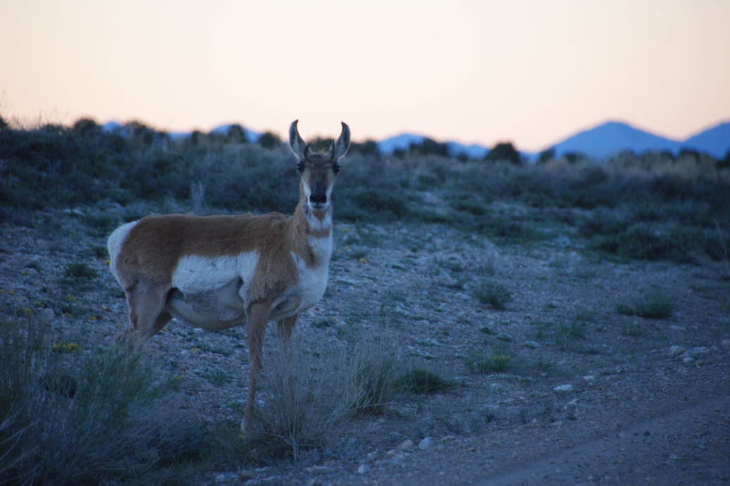
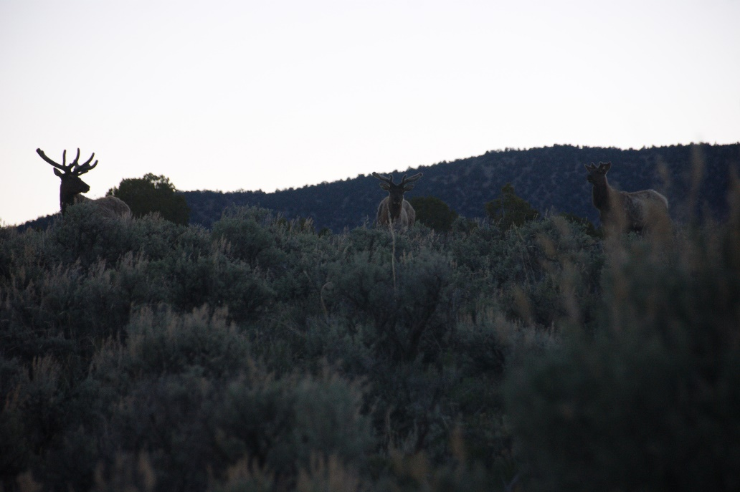

PJ Project Group Norms

Field work can be tiring, challenging, and unpredictable. The best way to combat this is to be prepared for the worst, work together, and not be easily flustered. Our group norms are therefor set around doing the least amount of harm to each other and our surroundings during our work.
- Make sure you and those around you are comfortable. Privacy can be hard to come by in the sagebrush, but you may also feel less safe alone. Communicate with those around you. “Can I move my tent closer to yours?” “Can you stay on the other side of the truck for a minute?”
- Share with those around you. Food is communal, but also make sure that you and others have what you need. If you forgot something and need to borrow it, ask someone who did bring it. If you packed something valuable for the week, let others use it, too.
- You’re not a gender detective. If you don’t know someone’s preferred pronouns, just ask.
- Talk to, not about. Instead of things like, “ugh, I can’t believe Danielle is so bad at explaining things,” say “hey, Danielle, could you please explain to me how to distinguish between a deer mouse and a pinyon mouse again?”
- Take out the trash! If you see litter, pick it up and take it out of the field with us. Be mindful of individually wrapped items that produce little slivers of trash that can be easily blown away, lost, or forgotten.
- Be kind. Be conscious of any possible harm you could be doing to the environment or other organisms around you. This applies to your fellow people, too! If something goes wrong, support each other in finding a solution instead of pointing fingers or degrading someone’s character.
Student Packing List
Required:
- Sunscreen
- Sunglasses
- Hat for blocking sun
- Hat for warmth at night
- Head lamp and extra batteries
- Limit clothes to one duffle bag size
  - Wool/warm/hiking socks
    - Pro-tip: keep one pair inside the bottom of your sleeping bag reserved only for that purpose
  - Layers for dramatic temperature change (hot during day, cold at night)
    - Sweatpants for putting under field pants and for sleeping in
    - Sweatshirt or jacket for night time data collection and sleeping
    - Variety of shirts (tanks, tees, quick dry, flannel, long sleeves, etc.)
  - 2-3 pairs of pants for a week is optimal
  - If your pants don’t zip off and you want shorts, layer them underneath
- Bring another backpack for carrying things through the transects. This is a good place to store your sunscreen, sunglasses, and any other personal items you may need. We have a first aid kit, but I recommend bringing some bandaids, ankle tape, and anything that is specific to your own needs like allergy meds, personal vitamins, etc.
- Warm sleeping bag
- Sleeping mat/pad
- Tent (if you are in need of this type of camping supplies, I need advanced notice to arrange)
- Notebook and pencils
- Snacks that you enjoy for quick breakfasts or eating throughout the hikes. Please send advanced notice of any dietary restrictions or needs
- 1 bowl
- 1 set silverware
- Hiking boots
- Water bottle and/or camelback
- Tooth brush and tooth paste
- Baby wipes (the chance of shower will be low)
- Toilet paper
- Identification and back up money in case of unexpected purchases, fast food, pit stops, etc.
- Watch
- Phone charger
- Towel and wash cloth
- Deodorant
Optional:
- Beer/wine/alcoholic beverage if you participate in such things
- If you wear contacts, it is recommended that because of all of the dust and suboptimal conditions for contact liquid that you wear glasses instead
- If you are reliant of caffeinated beverage, travel mug, tea, individual coffee press (GSI makes a great one), etc.
- Knife/gun/whistle/mace
- Field guides
- Swimsuit
- Something to entertain yourself during possible freetime (book, instrument, drawing pad, etc – there won’t likely be internet access)
- Portable phone batteries
- If you have one, bring your camera and a way to charge it or extra batteries and extra memory card
- Fingernail clippers/way to clean your fingernails
- If you have one, please, please, please bring your handheld GPS and a way to charge it or extra batteries (like a garmin used for geocaching not for car navigation)
- Flipflops or slip-on shoes to wear at campsite
- If you have long hair, bring hair ties and brush
- Batting or gardening gloves if you want to handle small mammals and reduce chances of animal bites
- Bug spray
- Chapstick, aloe, lotion, hand sanitizer
- Lantern for at camp or in tent and extra batteries
- If you think of something that you have that could be useful and are on the fence about packing it just shoot me your idea and I’ll get back to you. Chances are it would be useful!

